Vivian Lapis 4060 A St. Springfield, OR 97478
Vivian.Lapis@gmail.com
Student number: 23175114
Computer Forensics, CIS
Project number: 445819
Knoppix is an ISO image for Linux that may be launched straight from a bootable CD or USB stick; no installation of the software is necessary on the host. It’s a beneficial tool for system repair, data recovery, network analysis, and general computing.
With its comprehensive office suite containing applications such as LibreOffice, providing users with word processing, spreadsheet, presentation, and database management tools. To accommodate varying tastes, the ISO includes text editors like Vim, Nano, and Leafpad, catering to different preferences for coding or general text editing.
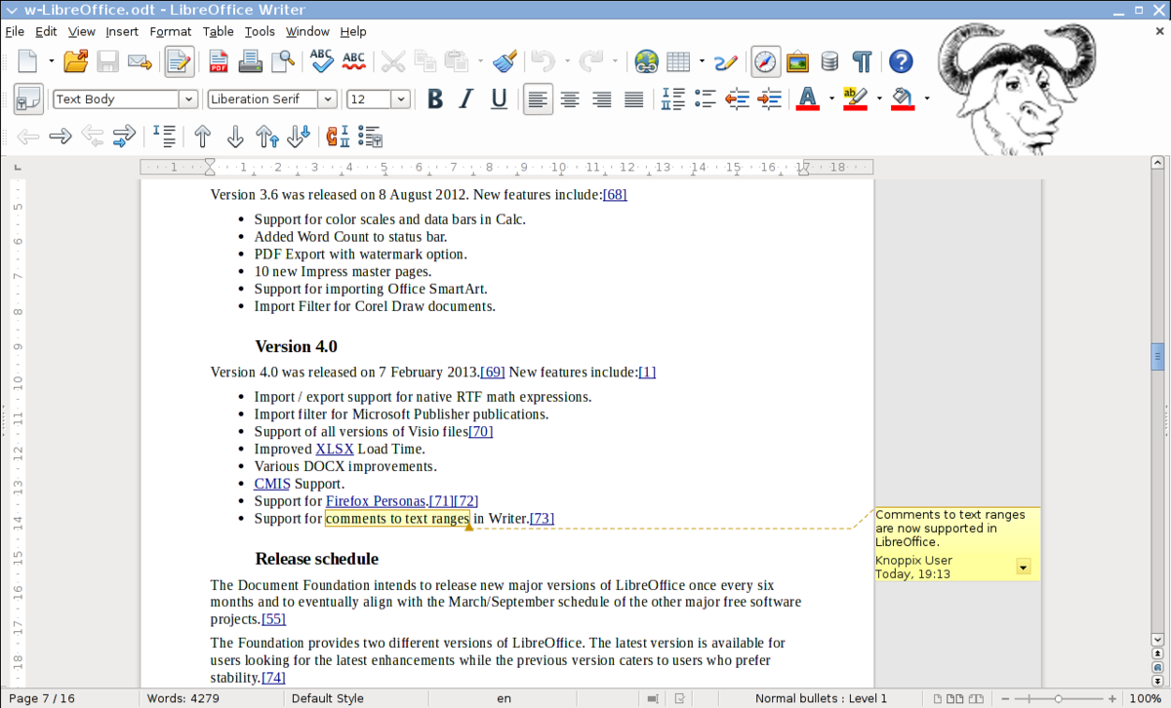
The Chromium and Firefox browsers come preinstalled on it. These browsers have plugins and extensions to improve the browsing experience and guarantee websites work properly.
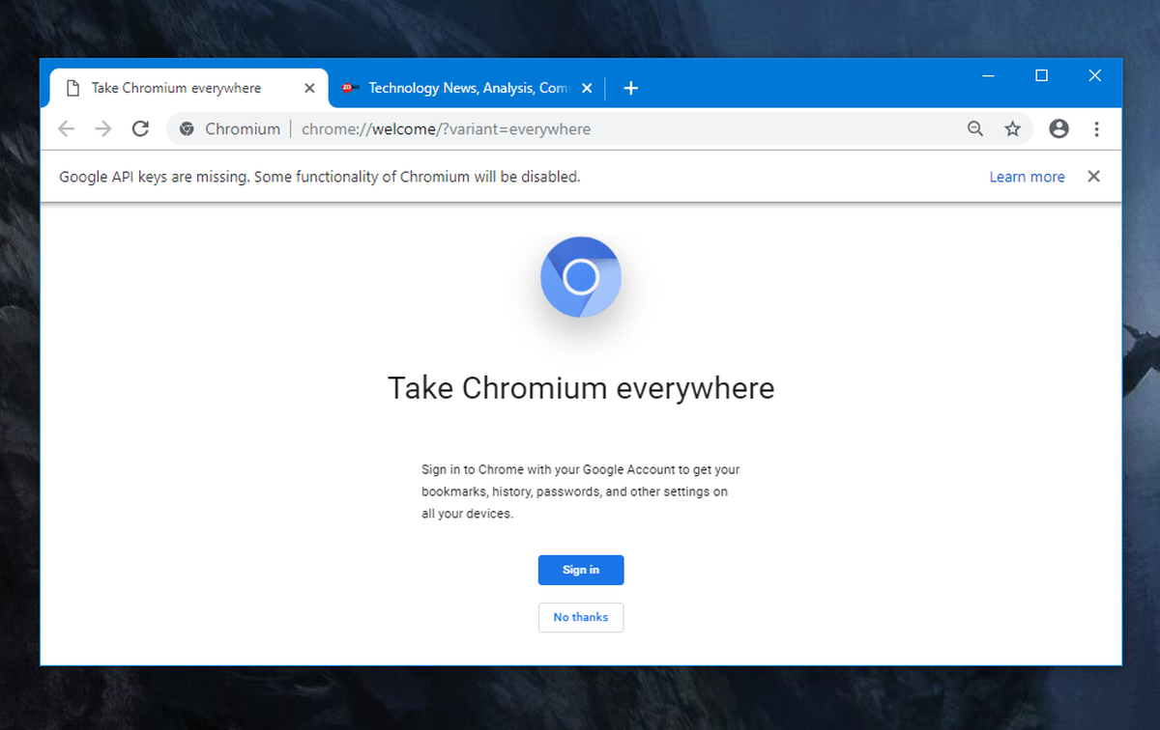
A network protocol analyzer called Wireshark Wireshark is included for capturing and inspecting data packets in real-time. This tool can be used to diagnose network issues, analyze traffic, and detect security breaches. Nmap, a network scanning tool, allows packet inspection and capture.
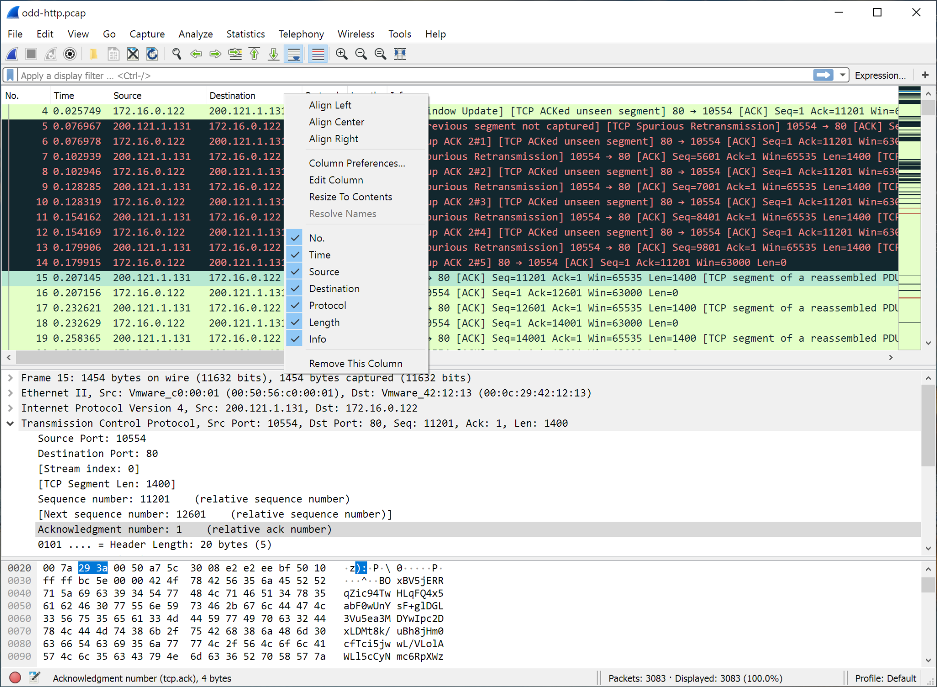
Disk management tools like GParted partition editor let users format, create, and resize partitions on their drives. This is helpful for managing disk space or for a new drive installation. The Clonezilla imaging program, which may be used to clone hard drives or make system backups, is also included with Knoppix.
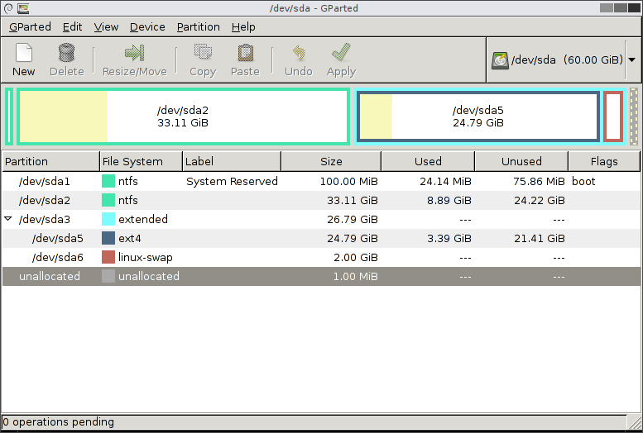
For security and forensic analysis, Knoppix is equipped with tools like John the Ripper and Chntpw. A password-cracking tool called John the Ripper is used to find forgotten or weak passwords and test their strength. Chntpw, on the other hand, allows users to reset Windows passwords, giving them access to their computers again without having to reinstall the operating system on them. These tools are critical for security professionals conducting penetration testing or forensic investigations.
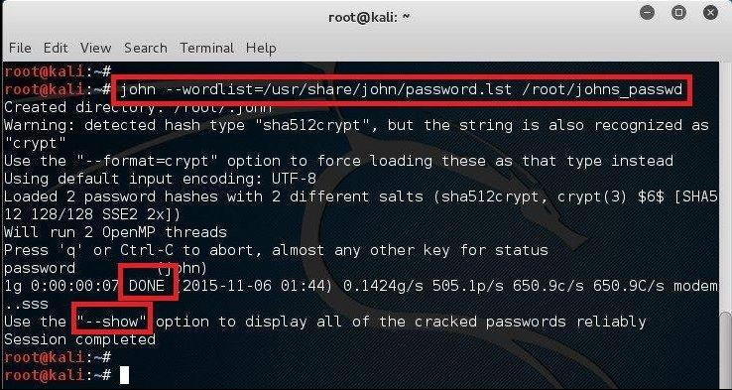
Compilers for a number of programming languages are available on Knoppix, including Python, Perl, and GCC (GNU Compiler Collection) for C and C++. It also comes with version control systems like Git which enables developers to manage their source code repositories.
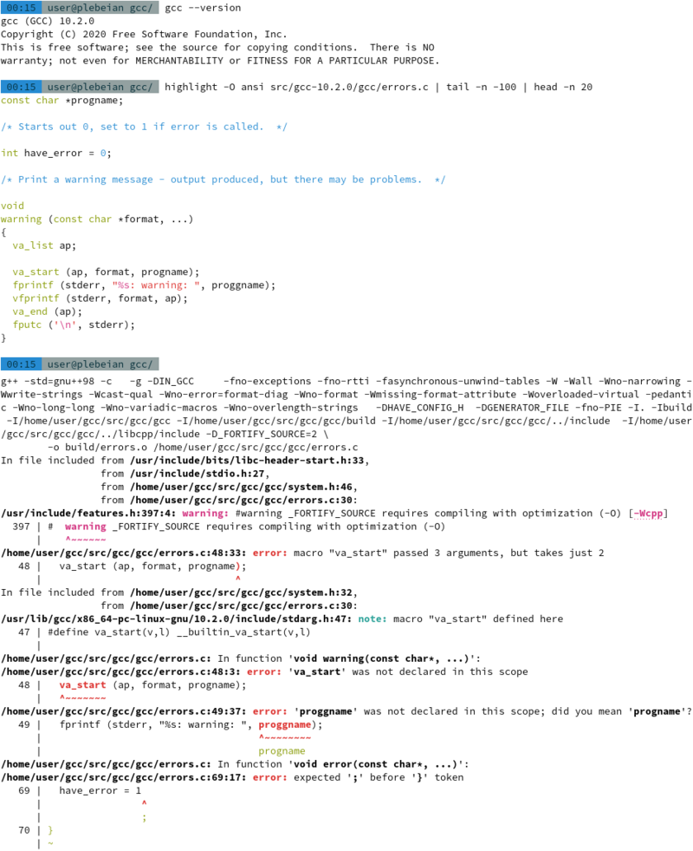
For multimedia capabilities, it includes VLC Media Player, a versatile media player that can handle almost any audio or video format. For audio editing, Audacity is preinstalled, offering recording and editing of audio files. For image editing, it comes with GIMP, an image editing program similar to Adobe Photoshop.
